Luis A Fierro:

4. Design an "anticipatory set" activity. -A worksheet will be given while playing an interesting video of masks around the world. The worksheet is for the students to draw a fun mask.
6. Make a worksheet that helps students transition into the activity.
7. Group coordinator: organize the group, take notes and conduct meetings, organize communication

Tlaloc is the Aztec god is the god of rain, lightning, and thunder. He is a fertility god, but also a wrathful deity. He is responsible for both floods and droughts.
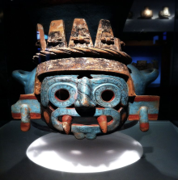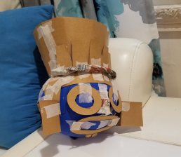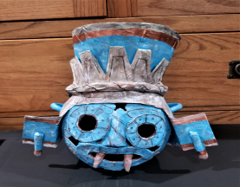
Ganesha is in Hindu tradition the son of Lord Shiva. It is a native animal of India and Ganesha represents the removal of obstacles especially when starting a new business. He is a symbol of strength and power.
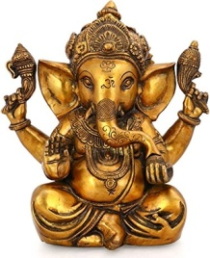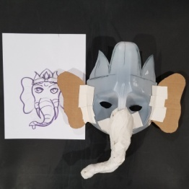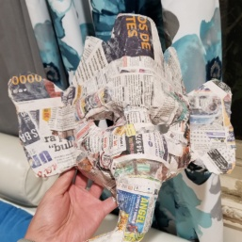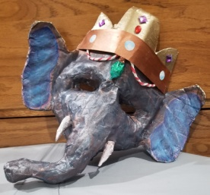
The worksheet has the students connect the native people with their sculptural artwork representing their heritage. We will then talk about the correct answers and it will be a transition from researching about native cultures to drawing a mask.
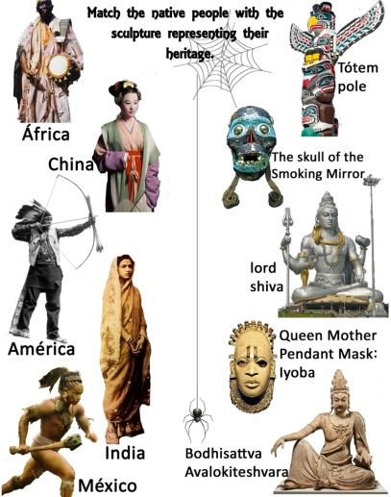

Marina Vihena:

1. Create an art history presentation
8. Presentation organizer (makes a PPT/presentation that brings all portions together for final presentation)

Omulu is an orixá from Candomblé —a Brazilian religion that absorbed elements of African beliefs, Roman Catholicism, and includes indigenous American traditions. Orixás act as intermediaries between humans and the Supreme Being, deities of several major religions in the African diaspora.
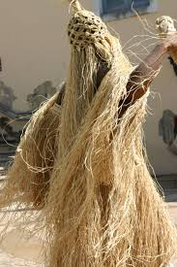

Diana Lopez:
3. Create a grading sheet
5. Write a lesson plan with Briana

In Mayan mythology, the Jaguar was seen as the ruler of the Underworld, and as such, a symbol of the night sun and darkness.
Tlaloc is the Aztec god is the god of rain, lightning, and thunder. He is the son of Ometecuhtli y Omecihuatl.
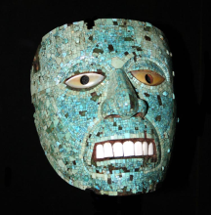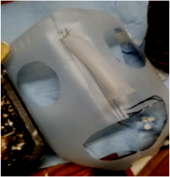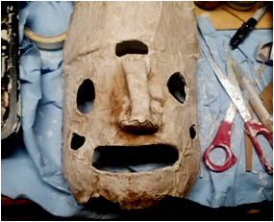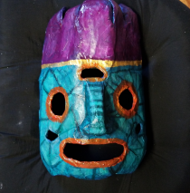

Jaguar/Ek Balam Aztec god of the Sun who transformed himself into a jaguar at nights, so he could travel to the underworld.
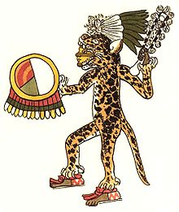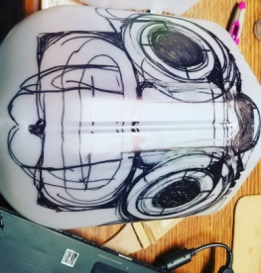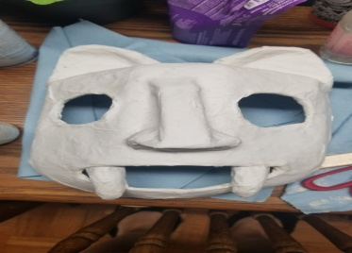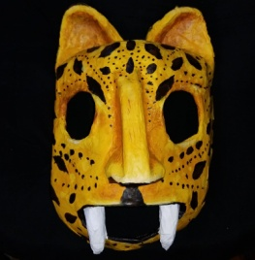
Briana Landeros:

2. Create a step by step instruction sheet and/or FAQ
5. Write a lesson plan with Diana
Kitsune is the Japanese word for fox – a form of yokai, which is a type of supernatural being from Japanese folklore. In Japanese culture, the fox can be perceived as good or evil and is also able to shift into human forms. Depicted as intelligent beings, they get stronger with the years.
